**PROJECT OF AUTOMATIC TEMPERATURE CONTROLLER USING PIC 18F452 MICROCONTROLLER**

**Description of project**

**1-Design an automatic temperature controller using PIC 18F452 microcontroller and suitable I/O devices. Your system should display your name on the first line and the measured temperature on the second line in a 16x2 LCD.**

**Ans –** We have design automatic temperature control using 18f452 micro-controller as suitable of input and output port. We have design to using a proteus professional software and display name of first line and second line we can display measured temperature in 16*2 LCD display. This project there are 2 software used first is proteus professional 8 and second is mikroC complier..

**We can show image here**

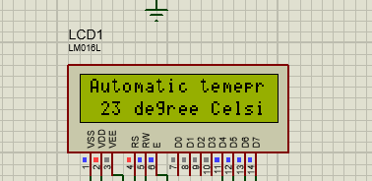

**The system should turn on a heater (you can represent it using filament lamp output in your simulation) if the measured temperature is below the set level.**

Ans – We can use heater in the model if the heater is turn on temperature is measured in lcd display as a set level.

**Here shows image**

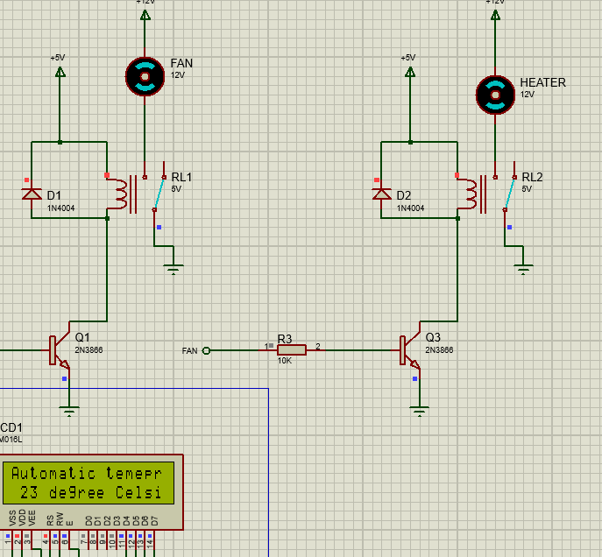

* **If the measured temperature is above the set value, a cooling fan should be switched on (You can use DC motor in your simulation)**

Ans – We can measure as a temperature when colling fan is turn on temperature is measured as lcd display as a set level.

**Here shows image**

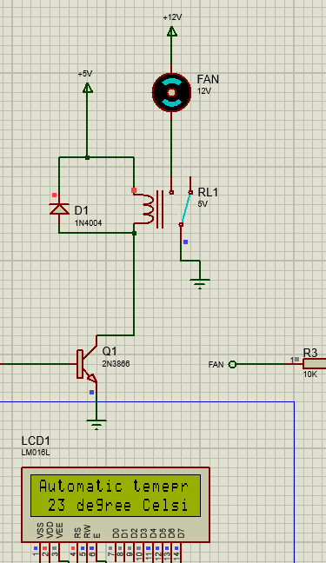

* **Block diagram of the project showing the components used in your design.**

**Ans –** We can use different type of components use in this project we can show here as all component.

 **= 1N4004**

 **= 2N3866**

 **= Capacitor(02013a3r3cat2a)**

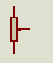 **= 3352t-1-202lf**

 **= button**

 **= crystal**

 **= erj-14y-j103u**

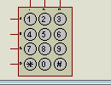 **= keypad phone**

 **= motor**

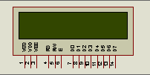 **= LCD display**

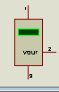 **= LM35**

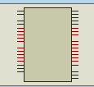 **= PIC18F452 micro-controller**

 **= POT**

 **= RELAY**

* **Description of the input/output you have used in your design and a brief description of the input/output ports of the microcontroller you have used to connect the components like switches, LCD and the range of measurement of voltage.**

**Ans –** We have written description of the design used in the project input/output port of micro-controller. We can connect many types of usable component in this project and measure the different voltage of all components. Here are show a measurement.

**Transmitter** – We can use in this project as 2n3866 transmitter. We can measure 5v in this component.

**Bourns Trimmer Resistors** – it is used to work of variable resistance. It is adjusted tune and calibration circuits. The value measure in this project is 2k

**Thick film resistor** – it is used to if the battery plug is thick then this is used there. The value measured in this project is 10k

**Relay** – it is behaved like a switch. We can measure the part value is 5v

**LCD** – we use 16*2 lcd it is used to work for display purpose. In this project we use display their name in first line and measured temperature as second lines. In the clock frequency is 250khz. This is used many types of work like pollution measured temperature measured.

**Switches** – in this project switch behave like change temperature data.

**Power source** – it is used to work on power in all new added component. The value measured is +5v

**Default** – it is work on heater fan and temperature regulation.

**Connection of components.**

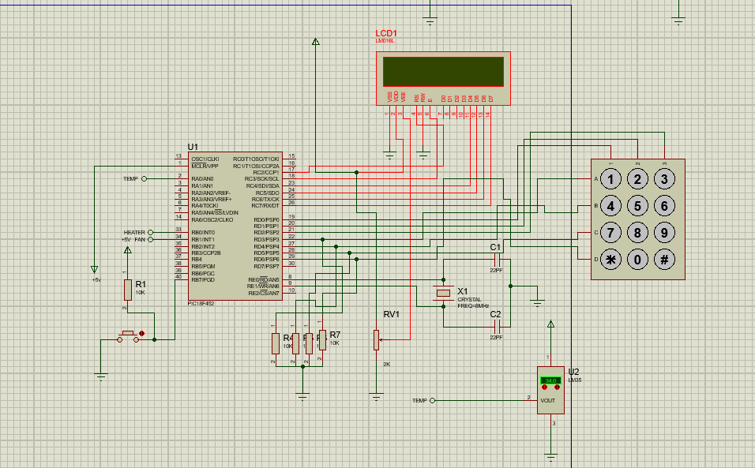

* **Flowchart or Algorithm showing the basic operation of the PIC microcontroller program**
* **The code of your PIC program in C using mikroC Pro compiler with appropriate comments.**

**Ans –** This is a code of automatic temperature controller using PIC 18F452 micro-controller in mikroC software pro complier. As well as we can write a comment in all particular line of code.

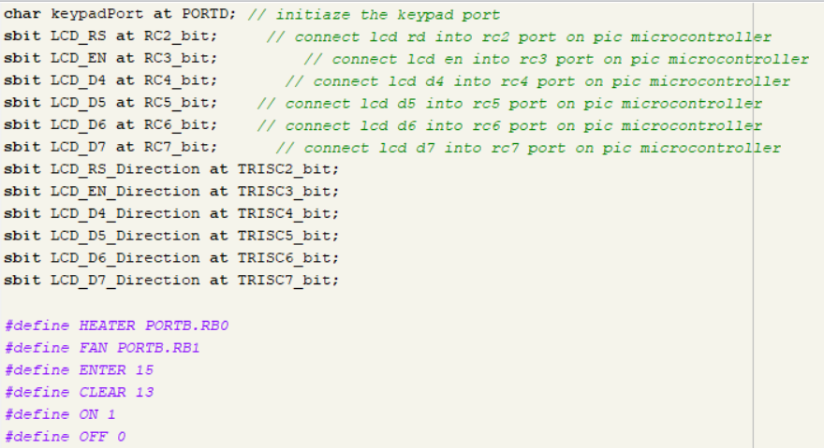

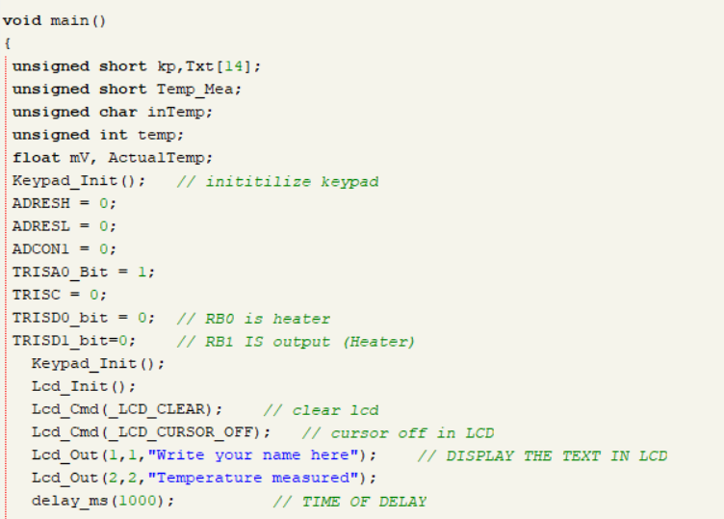

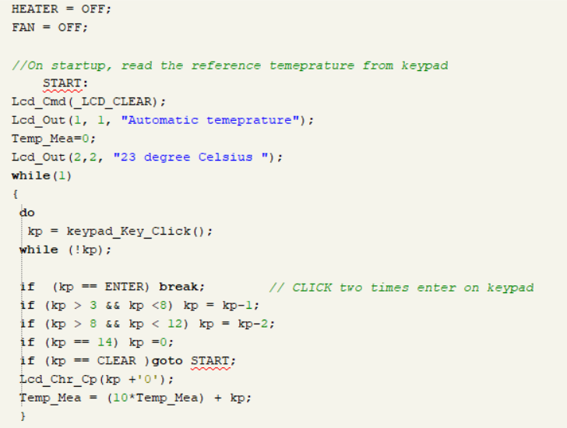

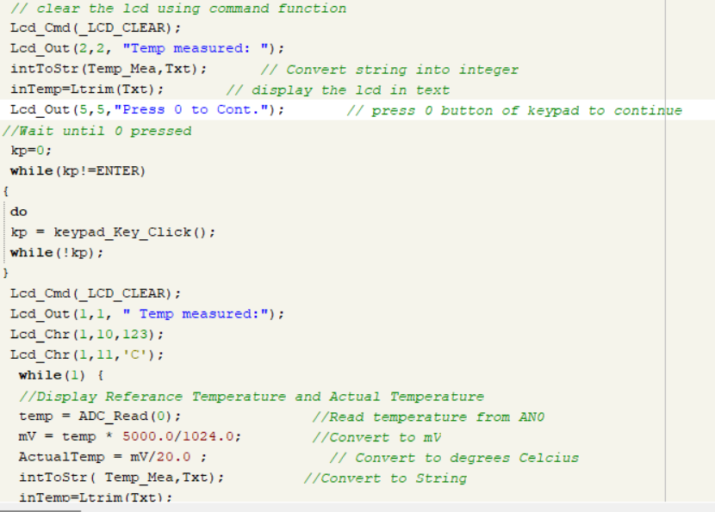

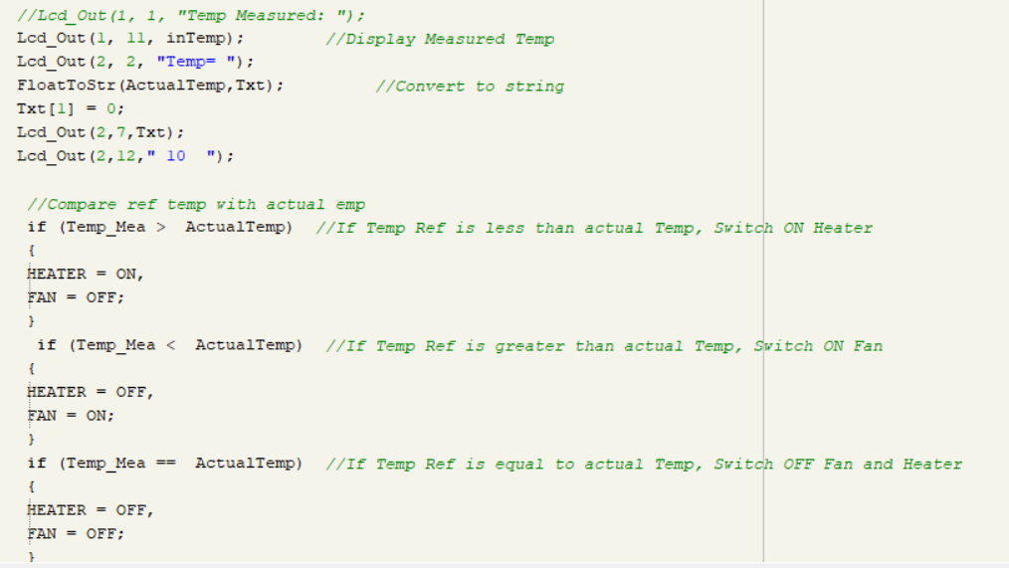

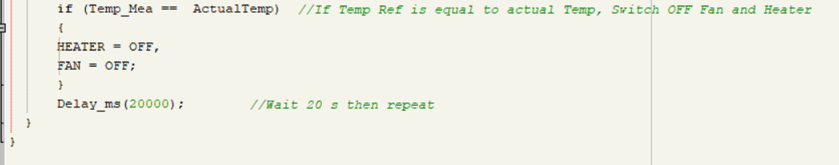

**Message of build after running**

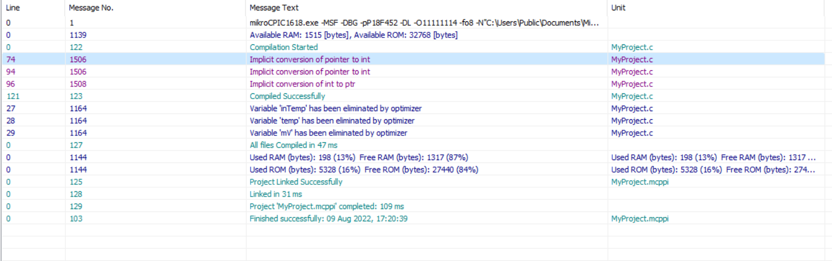

* **Simulation of your design**

**Ans –** We have simulated after import the code of pic micro-controller we have shown here an overall design of temperature before running. We can design of proteus professional 8 software

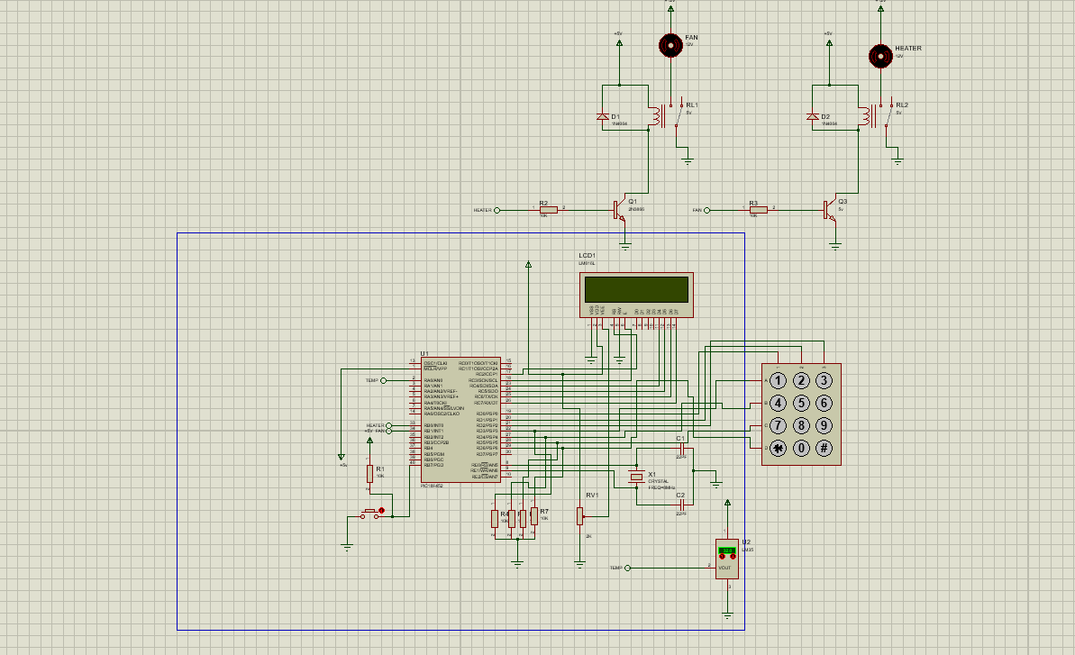

**Here shown a design after running**

